NXT Windmill
This project was made with lego parts to create a windmill-like robot. The blades will spin as the lever is turned. The robot connects to gears to amplify the power so that the blades will spin.

Here’s a little information over the topic of windmills:
The earliest windmills date back to 500-900 A.D. created by the Persians. The Persian windmills used wind power to mill grains. Modern windmills are now used to create electricity. To quote energy.gov : "The energy in the wind turns two or three propeller-like blades around a rotor. The rotor is connected to the main shaft, which spins a generator to create electricity."
Windmill Structure | NXT Windmill
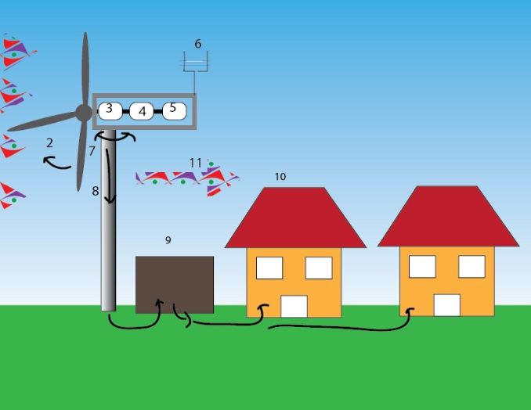 | 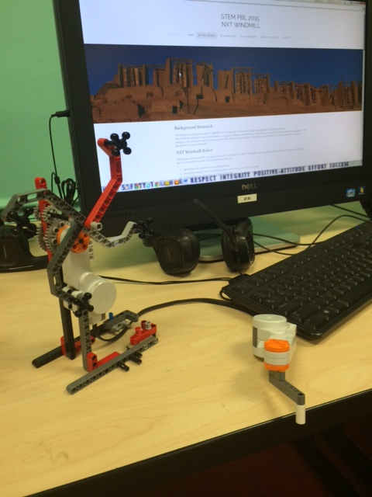
Flash Animated WindMill | Flash Animated WindMill
My Video | My Website

